Hospital Management System: A Data Analytics Report

1. Project Overview
This project presents a comprehensive analysis of hospital operations using structured healthcare data. The goal is to transform raw transactional data into meaningful insights that support decision making in areas such as revenue optimization, patient care, and operational efficiency.
The solution integrates:
- SQL-based relational database design
- Python (Pandas) for data preprocessing
- Power BI for interactive visualization

2. Database Schema & Data Model
The system is designed using a relational database model with strong entity relationships:
Core Tables:
- Patients – demographic and insurance details
- Doctors – specialization and experience
- Appointments – links patients with doctors
- Treatments – medical procedures and costs
- Billing – financial transactions and payment status
Relationships:
- One patient → many appointments
- One doctor → many appointments
- One appointment → one treatment
- One treatment → one billing record
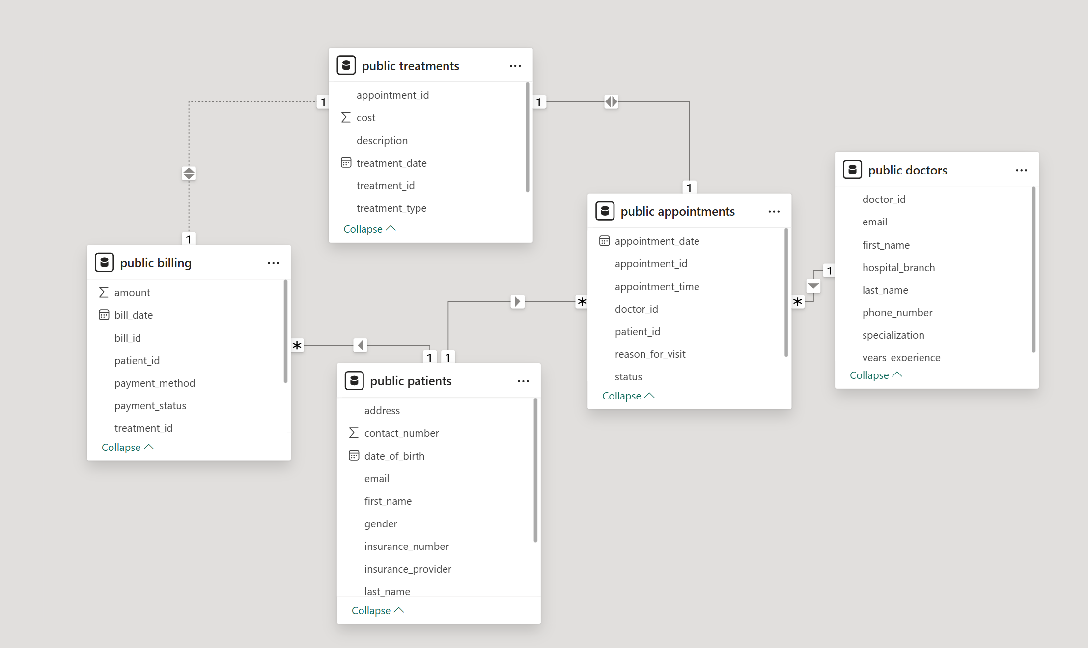
Key Insight:
This follows a star-like schema centered on appointments, making it ideal for analytical queries and BI tools.

3. Data Processing (ETL Pipeline)
🔹 Extraction
Data was imported from multiple CSV sources into a structured environment.
🔹 Transformation
Performed using Python (Pandas):
- Handled missing/null values
- Standardized date formats
- Cleaned categorical fields (payment status, specialization, etc.)
- Created derived metrics (e.g., revenue, averages)
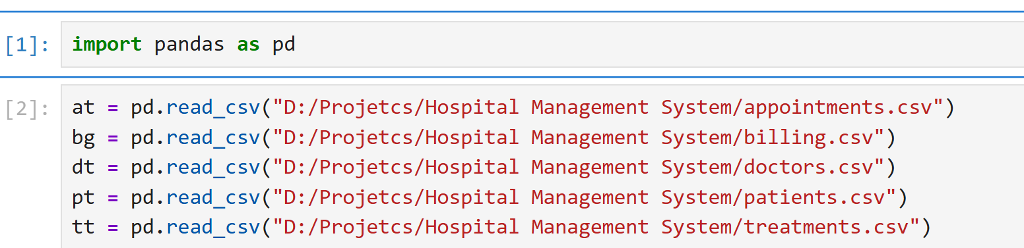
🔹 Loading
- Data stored in SQL database
- Connected to Power BI for visualization
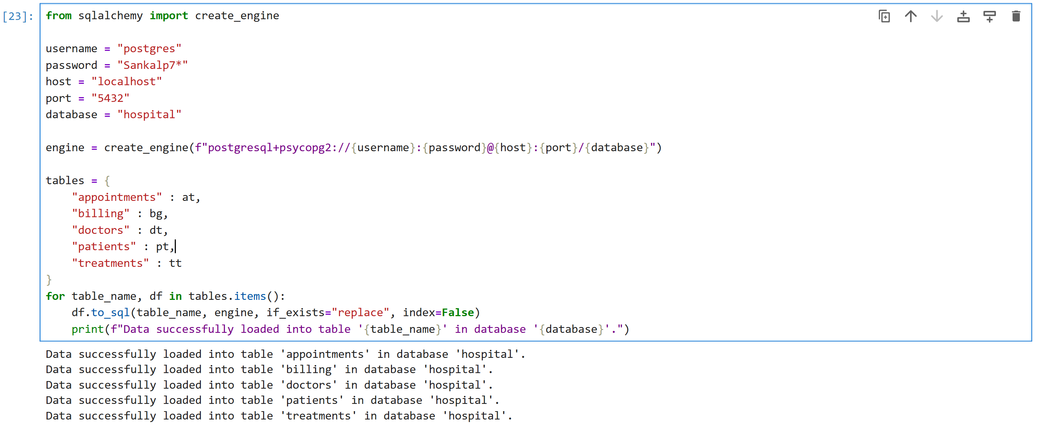
4. Dashboard Overview
The Power BI dashboard provides a centralized view of hospital performance.
Key KPIs:
- Total Revenue: $551.25K
- Total Appointments: 200
- Total Patients: 50
- Average Treatment Cost: $2.73K
- Payment Success Rate: 32%
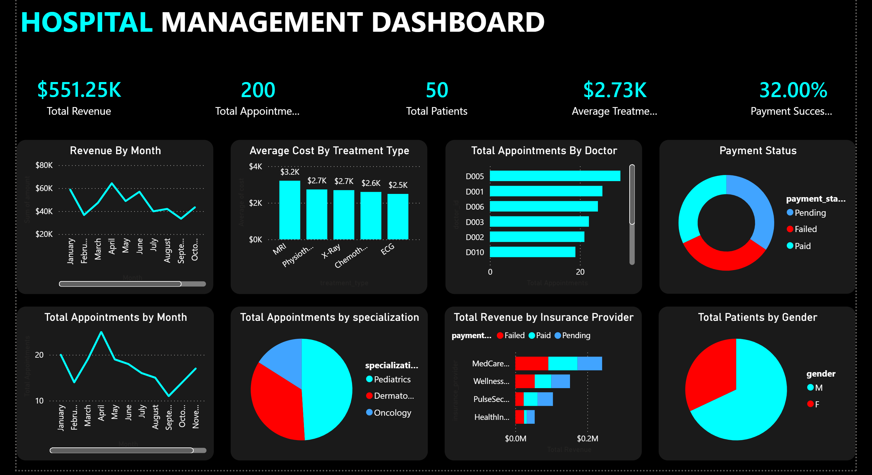
5. Key Insights & Analysis
- Revenue Trends
- Monthly revenue fluctuates significantly
- Peak observed around mid-year
- Drops in later months suggest seasonal or operational inefficiencies
Insight: Revenue instability indicates demand or scheduling issues.

- Payment Status (Critical Finding)
- Large proportion of failed and pending payments
- Only 32% success rate
Insight:
This is a major red flag — revenue leakage is high.
Business Impact:
- Cash flow problems
- Inefficient billing system
- Possible insurance processing delays

- Doctor Performance
- Certain doctors (e.g., D005) handle significantly more appointments
- Uneven workload distribution
Insight:
Resource utilization is imbalanced → burnout risk + inefficiency

- Treatment Cost Analysis
- MRI is the most expensive (~$3.2K)
- ECG is the least (~$2.5K)
Insight:
High-cost treatments contribute disproportionately to revenue.

- Appointment Trends
- Peak appointments around April
- Decline towards later months
Insight:
Demand variability → potential scheduling inefficiencies

- Specialization Distribution
- Pediatrics dominates
- Oncology has the least share
Insight:
Hospital demand is skewed → staffing and resource allocation should match demand.

- Insurance Revenue Analysis
- Majority revenue comes from specific providers (e.g., Medicare-like providers)
- Payment status varies across providers
Insight:
Some insurers may delay or fail payments more frequently.

- Patient Demographics
- Male patients significantly higher than female
Insight:
Could indicate demographic bias or dataset imbalance.

6. Key Problems Identified
🚨 1. Low Payment Success Rate (32%)
- Major revenue leakage
🚨 2. Uneven Doctor Workload
- Inefficient resource allocation
🚨 3. Revenue Instability
- Seasonal or operational issues
🚨 4. High Dependency on Few Insurance Providers
- Risk concentration

7. Recommendations
💡 Financial Improvements
- Implement stricter billing validation
- Automate payment follow-ups
- Improve insurance claim processing
💡 Operational Efficiency
- Balance doctor workload using scheduling optimization
- Forecast patient demand using time series models (fits your thesis 👀)
💡 Strategic Decisions
- Expand high-demand specializations (e.g., Pediatrics)
- Improve marketing or outreach in low-demand areas
💡 Data Improvements
- Track payment delays and reasons
- Add patient satisfaction metrics

8. Tools & Technologies Used
- SQL → Database design & querying
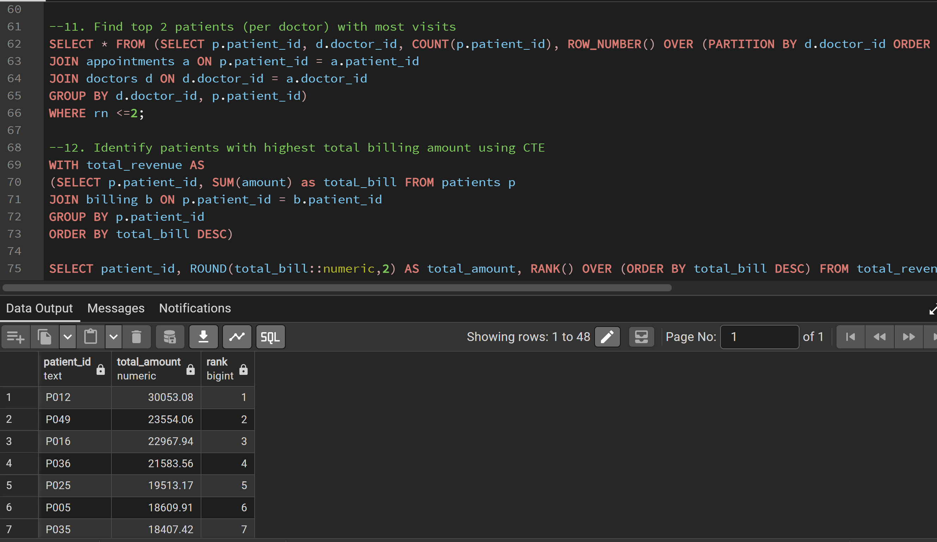
- Python (Pandas, NumPy) → Data cleaning & transformation
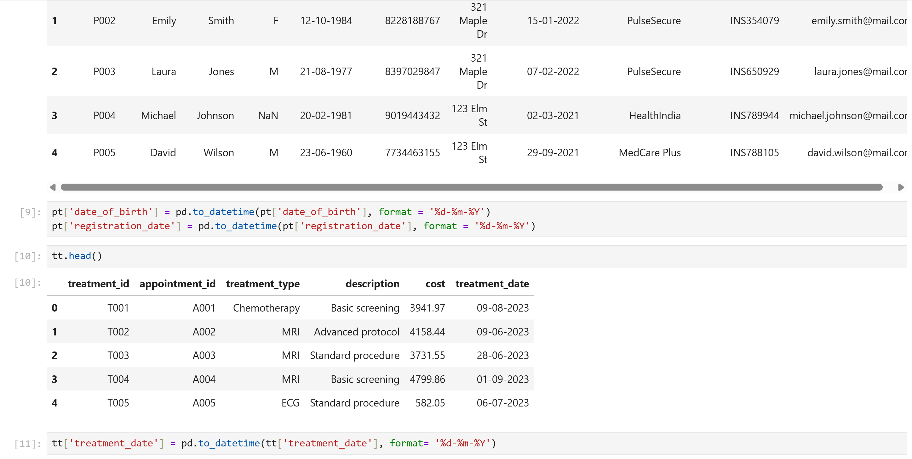
- Power BI → Data visualization & dashboarding

9. Conclusion
This project demonstrates how healthcare data can be leveraged to uncover operational inefficiencies and improve decision-making.
The analysis highlights critical issues such as:
- Low payment success rate
- Revenue inconsistency
- Resource imbalance
By implementing the recommended solutions, hospitals can significantly improve both financial performance and patient service quality.

